Master’s Research Project
Assignment 3: Business Process Mapping and Requirements Document
Developing an Information System to Optimize Supply Chain Operations for Sysco

School of Professional Studies, Saint Louis University
Professor: Annamaria Szakonyi
Due Date: 12th February 2025
By
Team 15

Bala Surya Peruri
Madhuri Pothu
Rasool Babu Yavara
Siva Ganesh Karthik Guptha Motamarri
Srikar Reddy Regatte
Venkata Rahithya Sopalli

Business Requirements Document (BRD) Gathering Template

- Business Process Mapping

Conduct a business process modeling activity for 1 main process of your product. Include the current state and future state with a separate diagram for each. You can use any tool to generate a graphical representation of the flow of work. Don’t forget to depict the usage and interaction between the various components – people, hardware and software.

As-Is (Current) Business Process Flow:
Currently, Sysco’s inventory management system relies on manual processes, which often lead to inefficiencies, delays, and unnecessary food waste. The workflow is as follows:
- Customer places an order.
- Warehouse staff manually check inventory.
They physically inspect stock availability.
They check expiration dates and verify stock levels against records.
- Stock availability decision:
If stock is available, the order is processed and prepared for delivery.
If stock is not available, warehouse staff manually place a restock order or delay fulfillment.
- Delivery to the customer.
Since the process does not account for customer order duration, products are assigned using a first-in, first-out (FIFO) approach, which does not always match customer needs.

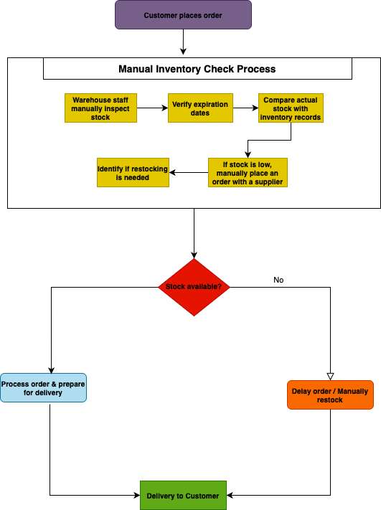
Yes
Future (Proposed) Business Process Flow:
The new system which we propose will incorporate automation, predictive analytics, and shelf-life management to ensure optimal order fulfillment. Our proposed workflow will be as follows:
- Customer places an order and specifies order duration.
- Automated inventory check retrieves stock data.
- System checks stock shelf life against requested order duration.
- Stock shelf life matches order duration.
If yes, the order is processed automatically.
If no, the system checks for alternative stock.
- Alternative stock available?
If yes, the system suggests an alternative product to the customer.
If no, the system auto-triggers restocking.
- Customer accepts alternative product.
If yes, the alternative product is assigned.
If no, the system waits for restocking.
- Optimized delivery to the customer.
We strongly believe that this updated process will reduce waste, ensure customer satisfaction, and optimize inventory turnover.

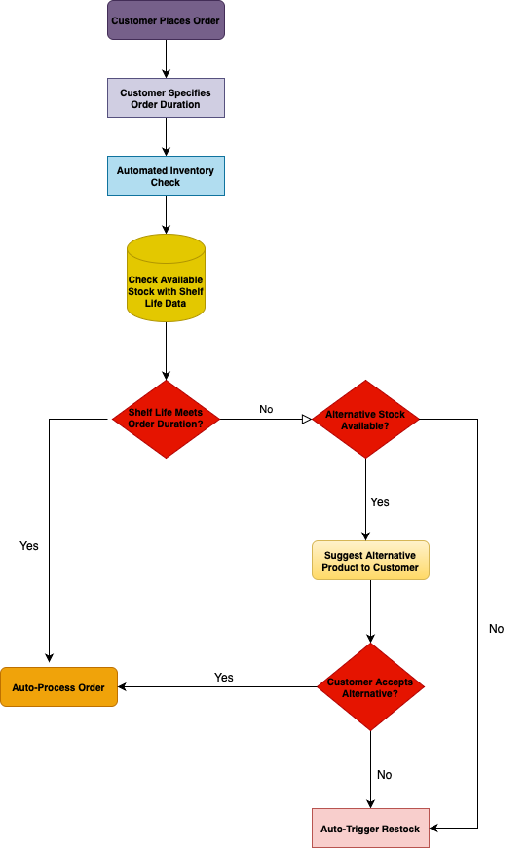
- Business Requirements

List the various requirements for your project. Include both the functional as well as the technical requirements.

Functional Requirements

Functional Requirement | Description
Real-Time Inventory Tracking | Our project will implement a real-time inventory tracking system that continuously monitors stock levels and updates them automatically as transactions occur. This system will eliminate manual inventory checks by warehouse staff and provide instant visibility into stock availability. By integrating with barcode scanners and IoT sensors, it will ensure that inventory records are always up to date, reducing errors, preventing overstocking or understocking, and improving overall warehouse efficiency.
Predictive Demand Forecasting | Our project will leverage machine learning algorithms to analyze historical sales data, seasonal trends, and market demand patterns to predict future stock requirements. This feature will help Sysco anticipate inventory needs, preventing shortages and reducing excessive stockpiling. The forecasting model will dynamically adjust predictions based on real-time sales data and external market factors, ensuring that warehouse managers can proactively manage inventory levels and maintain an optimal stock balance.
Automated Stock Replenishment | Our system will automate the stock replenishment process by triggering supplier restock orders when inventory reaches predefined thresholds. Instead of relying on manual intervention, the system will integrate with Sysco’s supplier network to automatically generate purchase orders, ensuring continuous availability of products. This feature will reduce lead times, improve supply chain coordination, and ensure that products are always available for customer orders without unnecessary delays.
Shelf-Life Management | Our project will introduce an advanced shelf-life management system that prioritizes stock allocation based on product expiration dates and customer order duration. Instead of using the traditional first-in, first-out (FIFO) method, our system will match inventory to customer needs by ensuring that products with an adequate shelf life are assigned accordingly. This feature will significantly reduce food waste, improve product quality, and ensure that customers receive products that remain fresh for their intended usage period.
Order Processing Automation | Our system will enable customers to specify how long they intend to use the product, allowing the inventory management system to allocate stock accordingly. This feature will check product shelf life before confirming the order, ensuring that customers receive items that match their required timeframe. By doing this, we will prevent situations where customers receive products that expire before their intended use, thereby improving order fulfillment accuracy and customer satisfaction.
Customer Order Tracking | Our system will allow customers to either accept an alternative product or wait for the requested product to be restocked. If a substitution is available, the customer will be notified through an automated system and given the option to approve the replacement or hold their order. This feature will ensure that customers have control over their orders while maintaining efficient inventory turnover and minimizing delays in order fulfillment.
Dashboard & Reporting | Our system will provide real-time visual analytics and reports on inventory levels, stock movement, sales trends, and demand forecasts. Warehouse managers will be able to access dynamic dashboards displaying key performance indicators (KPIs) such as stock turnover rates, product shelf-life utilization, and supplier fulfillment efficiency. This feature will help Sysco make data-driven decisions, optimize stock levels, and improve supply chain efficiency.

Technical Requirements

Technical Requirement | Description
System Integration | Our project will seamlessly integrate with Sysco’s existing ERP and inventory management systems to ensure real-time synchronization of stock levels, order processing, and supplier communication. This integration will eliminate manual data entry errors and create a unified digital ecosystem where all inventory data is centrally managed. The system will interact with logistics, procurement, and customer order processing systems to streamline warehouse operations.
Cloud-Based Infrastructure | We will host the system on AWS or Azure, providing scalability, high availability, and secure remote access. This cloud-based infrastructure will allow Sysco to scale up or down dynamically based on demand, ensuring system performance remains stable even during peak order periods. It will also support automated backups, disaster recovery solutions, and multi-location accessibility, ensuring business continuity in case of failures or disruptions.
Power BI Integration | We will integrate Power BI dashboards to provide real-time visualization of key metrics, such as inventory levels, sales trends, supplier performance, and stock shelf-life. These dashboards will allow Sysco’s management team to identify inefficiencies, predict demand, and make data-driven decisions. The reports will include interactive graphs, KPIs, and alerts, helping users analyze supply chain performance effectively.
APIs for Automation | We will develop RESTful APIs to automate real-time communication between inventory management, logistics, order processing, and supplier networks. These APIs will allow for automatic stock updates, order fulfillment tracking, and supplier coordination, eliminating the need for manual interventions. This automation will ensure faster processing times, reduced operational delays, and a more connected supply chain ecosystem.
Secure Access Control | We will implement role-based access control (RBAC), ensuring that only authorized users can access, modify, or approve stock-related data. Each user role, such as warehouse staff, inventory managers, suppliers, and system administrators, will have specific permissions to prevent unauthorized changes. The system will also include audit logs to track modifications, enhancing transparency and security.
Automated Alerts | Our system will include an automated notification engine that will send alerts for critical inventory events. This will include low stock warnings, product expiration alerts, supplier delays, and alternative stock suggestions. Notifications will be sent via email, SMS, and in-system alerts to warehouse managers, suppliers, and logistics teams, ensuring timely decision-making and proactive inventory management.

